Flowers in February
The 29th from 10-8pm
Come by the Hopkins District Library with something to grow a flower in!
~
We have the dirt and the flowers, you bring a ‘pot’ (the more creative the better!). We will have a few for you if you forget your.

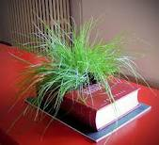

Together, we will bring a little bit of spring to Hopkins this February!

